Simulation and Modeling
Assignment-3

- The population of a certain country is 50 million and is expected to
double in 20 years. Calculate the population 5, 10, and 15 years from now by defining a vector t with 3 elements and using element-by-element alculations. Population growth can be modeled by the equation p=p02^t/d where P is the population at time t, 0 P is the population at t = 0, and d is the doubling time. Show the result by graph.

- Solve the Mass-Spring-Damper System:

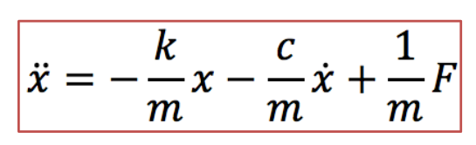

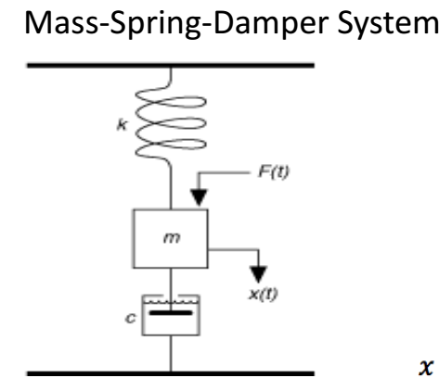

Hints: 